**Walmart Sales Analysis – Report**

**Capstone project**

**Dmt2Dmt3-Business Analytics and DigitalMarketing**

**Done by – Thirumoorthy.R**

**Summary**

A dashboard report is a visual representation of data that provides users with a quick and easy way to understand key metrics and trends. Dashboards are often used in business to track sales, marketing, and operations performance.To create a dashboard report, you will need to gather your data and then choose the right visualizations to display it. You should also consider the following tips for creating effective dashboards.

**Dashboard Overview**

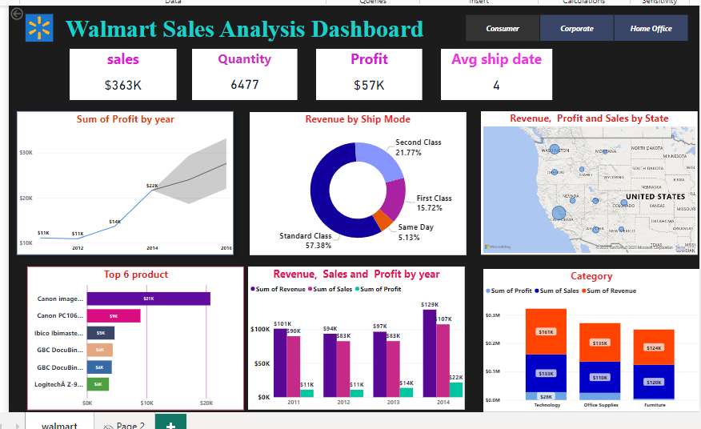

**Create a similar dashboard in excel :**

1. Import the necessary data into Excel. This data can come from a variety of sources, such as a CRM system, ERP system, or point-of-sale system.
2. Set up your workbook. Create a new workbook and give it a descriptive name. Then, create a worksheet for each section of your dashboard.
3. Add raw data to a table. On each worksheet, create a table to store your raw data. Be sure to include column headers for each metric that you want to track.
4. Data analysis. Once your data is in Excel, you can start to perform some basic data analysis. This may involve calculating percentages, totals, and averages.
5. Determine the visuals. What type of visualizations do you want to use to display your data? Some common options include bar charts, line charts, pie charts, and tables.
6. Create your Excel dashboard. Once you have determined the visuals that you want to use, you can start to create your dashboard. Add each visualization to the appropriate worksheet and position it where you want it.
7. Customize your dashboard. You can customize your dashboard by adding formatting, titles, and labels. You can also add filters and slicers to allow users to interact with your data.

**creating effective dashboards:**

* Group your related metrics. This will help users to understand the relationship between different metrics.
* Be consistent. Use the same colors, fonts, and chart types throughout your dashboard. This will create a more unified and professional look.
* Use size and position to show hierarchy. Place the most important metrics at the top of your dashboard and the least important metrics at the bottom.
* Give your numbers context. Don't just display raw data. Explain what the numbers mean and how they compare to previous periods.
* Use clear labels that your audience will understand. Avoid using jargon or abbreviations.
* Remember it's for people. Design your dashboard with your users in mind. Make sure it is easy to read and understand.
* Keep evolving your dashboards. As your business changes, so should your dashboards. Review your dashboards regularly and make updates as needed.

Page 2

.

**Three main sections:**

* This section provides a high-level overview of Walmart's sales, including total revenue, quantity sold, profit, and average shipping date.
* Revenue by Ship Mode: This section shows the percentage of Walmart's revenue that comes from each shipping mode (standard class, second class, and same day).
* Revenue, Profit, and Sales by State: This section shows a map of the United States, with each state colored according to its sales performance.

The dashboard also includes a number of interactive elements, such as the ability to drill down into specific product categories and time periods. This makes it easy for users to explore the data and gain insights into Walmart's sales performance.

**creating a dashboard report :**

1. Choose a dashboard tool. There are many different dashboard tools available, both free and paid. Some popular options include Tableau, Power BI, and Google Data Studio. Each tool has its own strengths and weaknesses, so it's important to choose one that's right for your needs.
2. Connect to your data source. Once you've chosen a dashboard tool, you'll need to connect it to your data source. This could be a database, spreadsheet, or other type of data file.
3. Prepare your data. Once your data is connected, you may need to prepare it for use in your dashboard. This may involve cleaning the data, removing errors, and formatting it in a way that's compatible with your dashboard tool.
4. Design your dashboard. Now it's time to start designing your dashboard. This involves choosing the right visualizations, widgets, and filters for your data. You'll also need to consider the layout of your dashboard and how you want to organize your information.
5. Publish your dashboard. Once your dashboard is designed, you can publish it so that it can be shared with others. Most dashboard tools allow you to publish your dashboard to the web, so that it can be accessed from anywhere.

Here is a more detailed breakdown of each step:

**Choose a dashboard tool**

When choosing a dashboard tool, there are a few factors to consider:

* Ease of use: Some dashboard tools are easier to use than others. If you're new to dashboarding, you may want to choose a tool that's easy to learn and use.
* Features: Different dashboard tools offer different features. Some tools are better suited for creating simple dashboards, while others are more powerful and can be used to create complex dashboards with interactive elements.
* Pricing: Dashboard tools can range in price from free to several thousand dollars per year. Choose a tool that fits your budget and needs.

Connect to your data source

Once you've chosen a dashboard tool, you'll need to connect it to your data source. This could be a database, spreadsheet, or other type of data file.

Most dashboard tools make it easy to connect to your data source. Simply follow the prompts in the tool to connect to your data.

Prepare your data

Once your data is connected, you may need to prepare it for use in your dashboard. This may involve cleaning the data, removing errors, and formatting it in a way that's compatible with your dashboard tool.

For example, you may need to remove duplicate rows from your data or convert dates to a specific format.

**Design your dashboard**

Now it's time to start designing your dashboard. This involves choosing the right visualizations, widgets, and filters for your data. You'll also need to consider the layout of your dashboard and how you want to organize your information.

Most dashboard tools offer a variety of different visualizations, widgets, and filters. Choose the ones that are best suited for your data and your audience.

When designing the layout of your dashboard, keep in mind that you want to make it easy for users to find the information they need. Group related metrics together and use clear labels.

Publish your dashboard

Once your dashboard is designed, you can publish it so that it can be shared with others. Most dashboard tools allow you to publish your dashboard to the web, so that it can be accessed from anywhere.

**The Walmart Sales Analysis Dashboard**

The Walmart Sales Analysis Dashboard you sent is a great example of a well-designed dashboard. It uses a variety of different visualizations to present data in a clear and concise way.

The dashboard is divided into several sections, each of which focuses on a different aspect of Walmart's sales. The first section shows an overview of Walmart's sales by year, quarter, and month. The second section shows a breakdown of sales by product category. The third section shows a breakdown of sales by state.

The dashboard also includes a number of interactive elements. For example, users can click on a bar in the sales by product category chart to see a more detailed breakdown of sales for that category.

Overall, the Walmart Sales Analysis Dashboard is a well-designed dashboard that is easy to use and understand. It provides users with a valuable overview of Walmart's sales data.